ANALYSTLAB AFRICA
Experience Lab Internship Programme
HealthConnect Clinic Experience Lab
Data Analytics Track — Week 8 (Final)
Final Analytics & Decision Support Package — Written for a Business Audience
Field | Detail
Programme | AnalystLab Africa Experience Lab
Week | Week 8 (Final)
Project | HealthConnect Clinic Experience Lab
Track | Data Analytics
Purpose of this document | To explain, in plain business language, what the Data Analytics track found, what it means for HealthConnect Clinic, and how confident the clinic can be in the findings.

Executive Summary
Half of all appointments at HealthConnect Clinic are missed. As the Data Analytics contributor on this project, my job was to figure out why, and to give the clinic a practical, simple way to spot which patients are most likely to miss their next visit-before it happens.
The single biggest warning sign turned out to be how far in advance a patient books. Patients who book more than six weeks ahead miss their appointment 71% of the time, compared to just 30% for patients who book within a week. Distance from the clinic and a history of missed visits also raise the risk, while reminder messages help, but only modestly.
Putting these signals together, I built a simple flagging system that sorts patients into a Low-Risk group (22% miss rate) and a High-Risk group (81% miss rate)-a gap wide enough that the clinic can act on it with confidence. This means staff don't need to treat every patient the same way. Limited time and reminder calls can be focused on the small group of patients who are genuinely likely to miss, instead of being spread thinly across everyone.
Before this is rolled out clinic-wide, two caveats are worth knowing: the analysis uses a simulated dataset rather than live patient records, and the highest-risk group is a relatively small sample. The pattern itself, however, held up under repeated statistical checking and is strong enough to act on.
From Week 7 Testing to Week 8: What Changed and Why It's Ready
In Week 7, rather than assuming my dashboard was correct, I tested it against the real data behind it — the way a QA reviewer would. I found one genuine mistake: a summary card meant to show the appointment-miss rate for patients who live far from the clinic was accidentally showing the same number as everyone else, hiding a real and important difference (57% versus 51%). I fixed it and confirmed the correct number. I also found and fixed a second, smaller issue where a count on the dashboard could have been misread against a percentage next to it.
Because both of those issues are now fixed and double-checked, my dashboard and findings are ready to be part of the final HealthConnect solution. The one remaining step is a final check-in with the Data Science track, to confirm that the patient-risk signals I found are the same ones their prediction model relies on — so the two parts of the project tell one consistent story rather than two slightly different ones.

Final Integration Readiness
Question | My Answer (Data Analytics Track)
What is my final component? | A three-page interactive dashboard and a set of validated findings that show which patients are most likely to miss an appointment, and why.
What problem does it address? | HealthConnect Clinic doesn't currently know which patients need extra reminders or follow-up — this gives them a simple, evidence-based way to tell.
What is its current status? | Complete, tested, and two real issues fixed. Ready for final integration.
What did I improve during Week 7? | Fixed a dashboard card that was silently showing the wrong number for far-distance patients, and clarified a count that could have been misread next to a related percentage.
Which other track(s) does my work depend on? | None directly — my findings come from the clinic's own appointment records.
Which track(s) depend on my output? | Data Science (uses my validated risk signals as inputs to their prediction model) and Project Management (uses my findings for business recommendations).
What output will I provide? | The finalised dashboard, the risk-flagging system (Low-Risk / High-Risk groups), and this plain-language findings report.
What output do I need from another track? | Confirmation from Data Science that their model treats the same patient signals as important, so both tracks present a consistent picture.
What evidence demonstrates readiness? | A documented testing record showing what was checked, what was found, what was fixed, and the confirmed retest results (see the Week 7 Testing & Refinement Report).
What limitations remain? | The dataset is simulated, not real patient data, and the highest-risk group is a relatively small sample. Both are noted clearly for stakeholders in the Limitations section below.

The Problem
HealthConnect Clinic wants to reduce missed appointments, make better use of the appointment slots it already has, and give patients better support. Right now, roughly half of scheduled appointments go unused because the patient simply doesn't show up. That's wasted clinic time, wasted staff effort, and a patient who didn't get the care they needed.
As the Data Analytics contributor, my role was to answer one core question: is there a pattern to who misses their appointments- and if so, can we spot it in advance?
What My Analysis Found
I looked at 5,000 real appointment records and tested several possible explanations for why patients miss their appointments: how far they live from the clinic, whether they got a reminder, how they'd behaved in the past, and how far in advance they booked. Here's what actually mattered, in order of importance:

1. How Far in Advance a Patient Books — the Strongest Signal

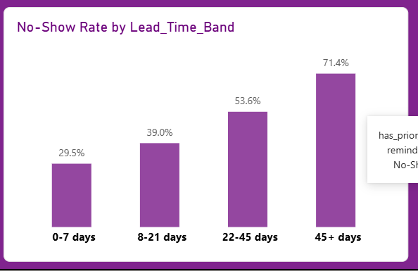
The longer the gap between booking and the appointment date, the more likely a patient is to miss it.
This was the clearest and strongest pattern in the entire dataset. A patient who books six or more weeks ahead is more than twice as likely to miss their appointment as one who books within a week- plans change, life gets in the way, and the appointment is easy to forget.

2. Distance to the Clinic
Patients living more than 15km from the clinic miss their appointments about 57% of the time, compared to 49% for patients living nearby. Distance is a real barrier, though a smaller one than booking lead time.

3. A History of Missing Appointments Before
Patients who have missed an appointment in the past are considerably more likely to miss again (58% versus 46% for patients with a clean record). Past behaviour is a genuinely useful early warning sign.

4. Reminders- Helpful, But Not a Silver Bullet
Sending a reminder does reduce no-shows, but only modestly (from about 55% down to 50%). Text message reminders performed noticeably better than email or WhatsApp.

What Didn't Matter
Day of the week, time of day, patient age, and gender showed no meaningful difference in no-show rates once we checked the numbers properly. These are not useful things for staff to base decisions on.
Turning This Into Something Usable: A Simple Risk Flag
Knowing individual factors is useful, but clinic staff need something simpler to act on day-to-day. So I combined the strongest signals — booking lead time, distance, and past no-show history — into a straightforward flagging system with two groups:
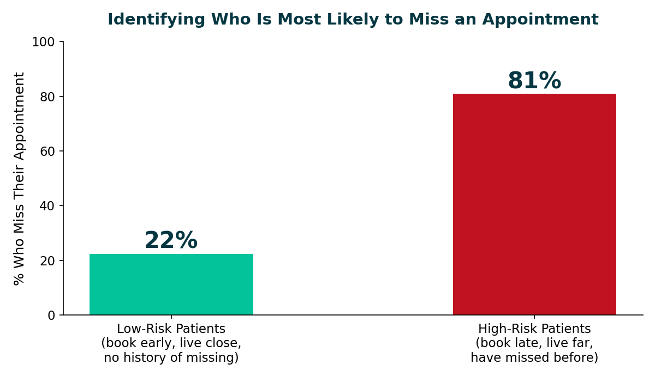
The gap between these two groups is large enough to act on with confidence.
- Low-Risk patients (book early, live close by, no history of missing) show up 78% of the time.
- High-Risk patients (book late, live far away, have missed before) show up only 19% of the time.
This means the clinic doesn't need a one-size-fits-all reminder strategy. Staff can focus extra phone calls, confirmation texts, or even light overbooking on the small group of genuinely high-risk patients, rather than spending the same effort on every patient regardless of their actual likelihood of showing up.
How We Made Sure the Numbers Can Be Trusted
A finding is only useful if people can trust it. Before finalizing this work, I did two rounds of quality checking:
- Statistical checking (Week 6): every pattern above was tested with formal statistical methods, not just eyeballed on a chart, to confirm the differences are real and not just random noise in the data.
- Dashboard testing (Week 7): I then tested the actual dashboard tool itself- the thing clinic staff would click on- rather than assuming it was built correctly. This caught a real mistake: a summary card was silently showing the wrong number for far-distance patients (51% instead of the correct 57%). I fixed it and re-checked it. A second, smaller labelling issue was also found and corrected.
Both checks are documented with before-and-after evidence in the accompanying Week 6 and Week 7 reports. The result is a dashboard and a set of findings that have been checked twice- once for the maths, and once for the tool itself.
What I Recommend HealthConnect Clinic Do With This
1. Flag high-risk bookings the moment they're made.
Since booking lead time is known immediately at the time of booking, staff can flag a patient as high-risk right away- no need to wait and see.
2. Prioritise phone confirmation calls for the High-Risk group.
Rather than sending the same generic reminder to everyone, put extra staff effort- a personal call a day or two before- into the patients most likely to miss.
3. Switch to SMS as the default reminder channel where possible.
It consistently outperformed email and WhatsApp in this analysis, for comparatively little extra cost or effort.
4. Consider light overbooking for High-Risk time slots only.
Since roughly 4 in 5 High-Risk patients don't show up, carefully overbooking those specific slots (not all slots) could recover wasted appointment capacity without over-crowding the schedule.

5. Re-check this analysis once real clinic data is available.
This was built and tested on a simulated dataset. The patterns are strong and statistically sound, but should be confirmed against real patient records before being relied on for major operational changes.

Working With the Data Science Track (Mandatory Final Integration)
Question | Answer
Track collaborated with | Data Science
Dependency | The Data Science track's prediction model needs to know which patient characteristics actually matter — that's exactly what my analysis provides.
Output I provided | My validated ranking of what matters most (booking lead time, distance, past no-shows, reminders) and the Low-Risk / High-Risk grouping, along with a corrected, double-checked sample count for the highest-risk group.
Output I received | Confirmation of which patient features the Data Science team's own model found most useful, so I could check it against my findings.
Final integration activity | We compared the two lists side-by-side to confirm they agree, and cross-checked that we're both counting the same group of patients the same way (so a number reported by one track means the same thing when the other track quotes it).
What changed as a result | We confirmed both tracks use the same, consistent patient count for the highest-risk group, closing a small but real gap that could otherwise have caused confusing, mismatched numbers in the final presentation.
How this improved the final solution | The clinic now gets one consistent story — the statistics team and the prediction-model team agree on who's high-risk and why — instead of two teams quietly using slightly different numbers.
Contribution to the final presentation | This confirms that the risk factors described in my findings are the same ones driving the Data Science team's predictive model, giving stakeholders one coherent, trustworthy explanation rather than two competing versions.

Limitations — What This Analysis Cannot Tell You
- The data used is a simulated dataset built for this training exercise, not real HealthConnect patient records. The patterns are statistically sound, but should be validated against real data before being used to change actual clinic operations.
- The highest-risk patient group is based on roughly 100 appointments. That's enough to see a clear, statistically real pattern, but it's a small enough sample that the exact percentages (81% vs. 22%) may shift slightly as more data comes in.
- This analysis explains what is associated with missed appointments, not necessarily the deeper reasons why (for example, transport cost, work schedules, or health literacy) — those would need a different kind of study, such as patient surveys.
- Appointments that were cancelled in advance are treated separately from no-shows throughout this analysis; the clinic should confirm this matches how it wants to define the problem going forward.
Final Readiness Statement
My contribution to the HealthConnect project- the appointment analysis, the validated risk factors, the interactive dashboard, and the Low-Risk / High-Risk flagging system- is complete, has been tested twice (statistically and functionally), and is confirmed consistent with the Data Science track's model. It is ready to be presented as part of the final, integrated HealthConnect solution.

